.
ASEAN Conference on Drug Use Prevention
International Standards
December 5-7, 2016

This Conference is anchored on the international global standards which summarize the currently available scientific evidence, describing interventions and policies that have been found to result in positive prevention outcomes and their characteristics. Concurrently, the global International Standards identify the major components and features of an effective national drug prevention system. It hopes to guide policymakers worldwide to develop programs, policies and systems that are truly effective investment in the future of children, young people, families and communities. It builds on and recognizes the work of many organizations (e.g. EMCDDA, CCSA, CICAD, Mentor, NIDA, WHO) which have previously developed standards and guidelines on various aspects of drug prevention.

The primary objective of drug prevention is to help people, particularly, but not exclusively young people, to avoid or, delay initiation into the use of drugs, or if they have started already, to avoid developing disorders (e.g. dependence). The general aim of drug prevention, however, is much broader than this: it is the healthy and safe development of children and youth to realize their talents and potential and become contributing members of their community and society.

In a nutshell, drug prevention is an integral part of a larger effort to ensure children and young people are less vulnerable and more resilient to drug use.

Reference:
https://www.unodc.org/documents/prevention/UNODC_2013_2015_international_standards_on_drug_use_prevention_E.pdf

Some Nearby Hotels / Dorms | Address | Contact Details
UP NISMED Hostel | Quirino Ave. cor. Velasquez St., U.P. Campus  Diliman, Quezon City, 1101 | http://www.nismed.upd.edu.ph/  upnismed_hostel@yahoo.com  (632) 981-8500 local 3901 up to 3910 ext. 102  (632)927 4276; (632)928 1563; (63) 918 4202745
SEAMEO  INNOTECH | Common-wealth Ave.,  UP Diliman, Quezon City 1101 | www.seameo-innotech.org  info@seameo-innotech.org  Fax: (632) 921-0224, 928-7692
Microtel by Wyndham - UP TechnoHub | Commonwealth Avenue, UP Ayala Land Technohub, Quezon City, 1121 | microtelbywyndham-uptechnohub.com  Telefax:  (632) 804 6888
The Sulo Riviera | Matalino Road, Diliman,  Quezon City 1101 | www.sulohotel.com.ph  Tel: (632) 924 -5051  Fax: (632) 922-2030
University Hotel | Guerrero St. Corner Aglipay  UP Campus, Diliman,  Quezon City 1101 | updilimanhotel@gmail.  com  updilimanhotel@  googlepages.com  Tel: (632) 926-1993
UP School of Labor and Industrial Relations Dormitory | UP Campus, Diliman  Quezon City | solair@up.edu.ph  www.solair.edu.ph  www.cleared.com.ph  Telefax:  (632) 928-6396
Local Water Utilities  Admn. Residence | Katipunan Ave., Diliman  Quezon City | http://www.lwua.gov.ph/  lwua@mozcom.com  Fax: (632) 4340973  (63) 916 6980805
Fersal Hotel Diliman | 131 Malakas St., Diliman  Quezon City | www.fersalhotel.com.ph  Fax: (632) 926-5140  Tel: (632) 426-7308




University of the Philippines
College of Education
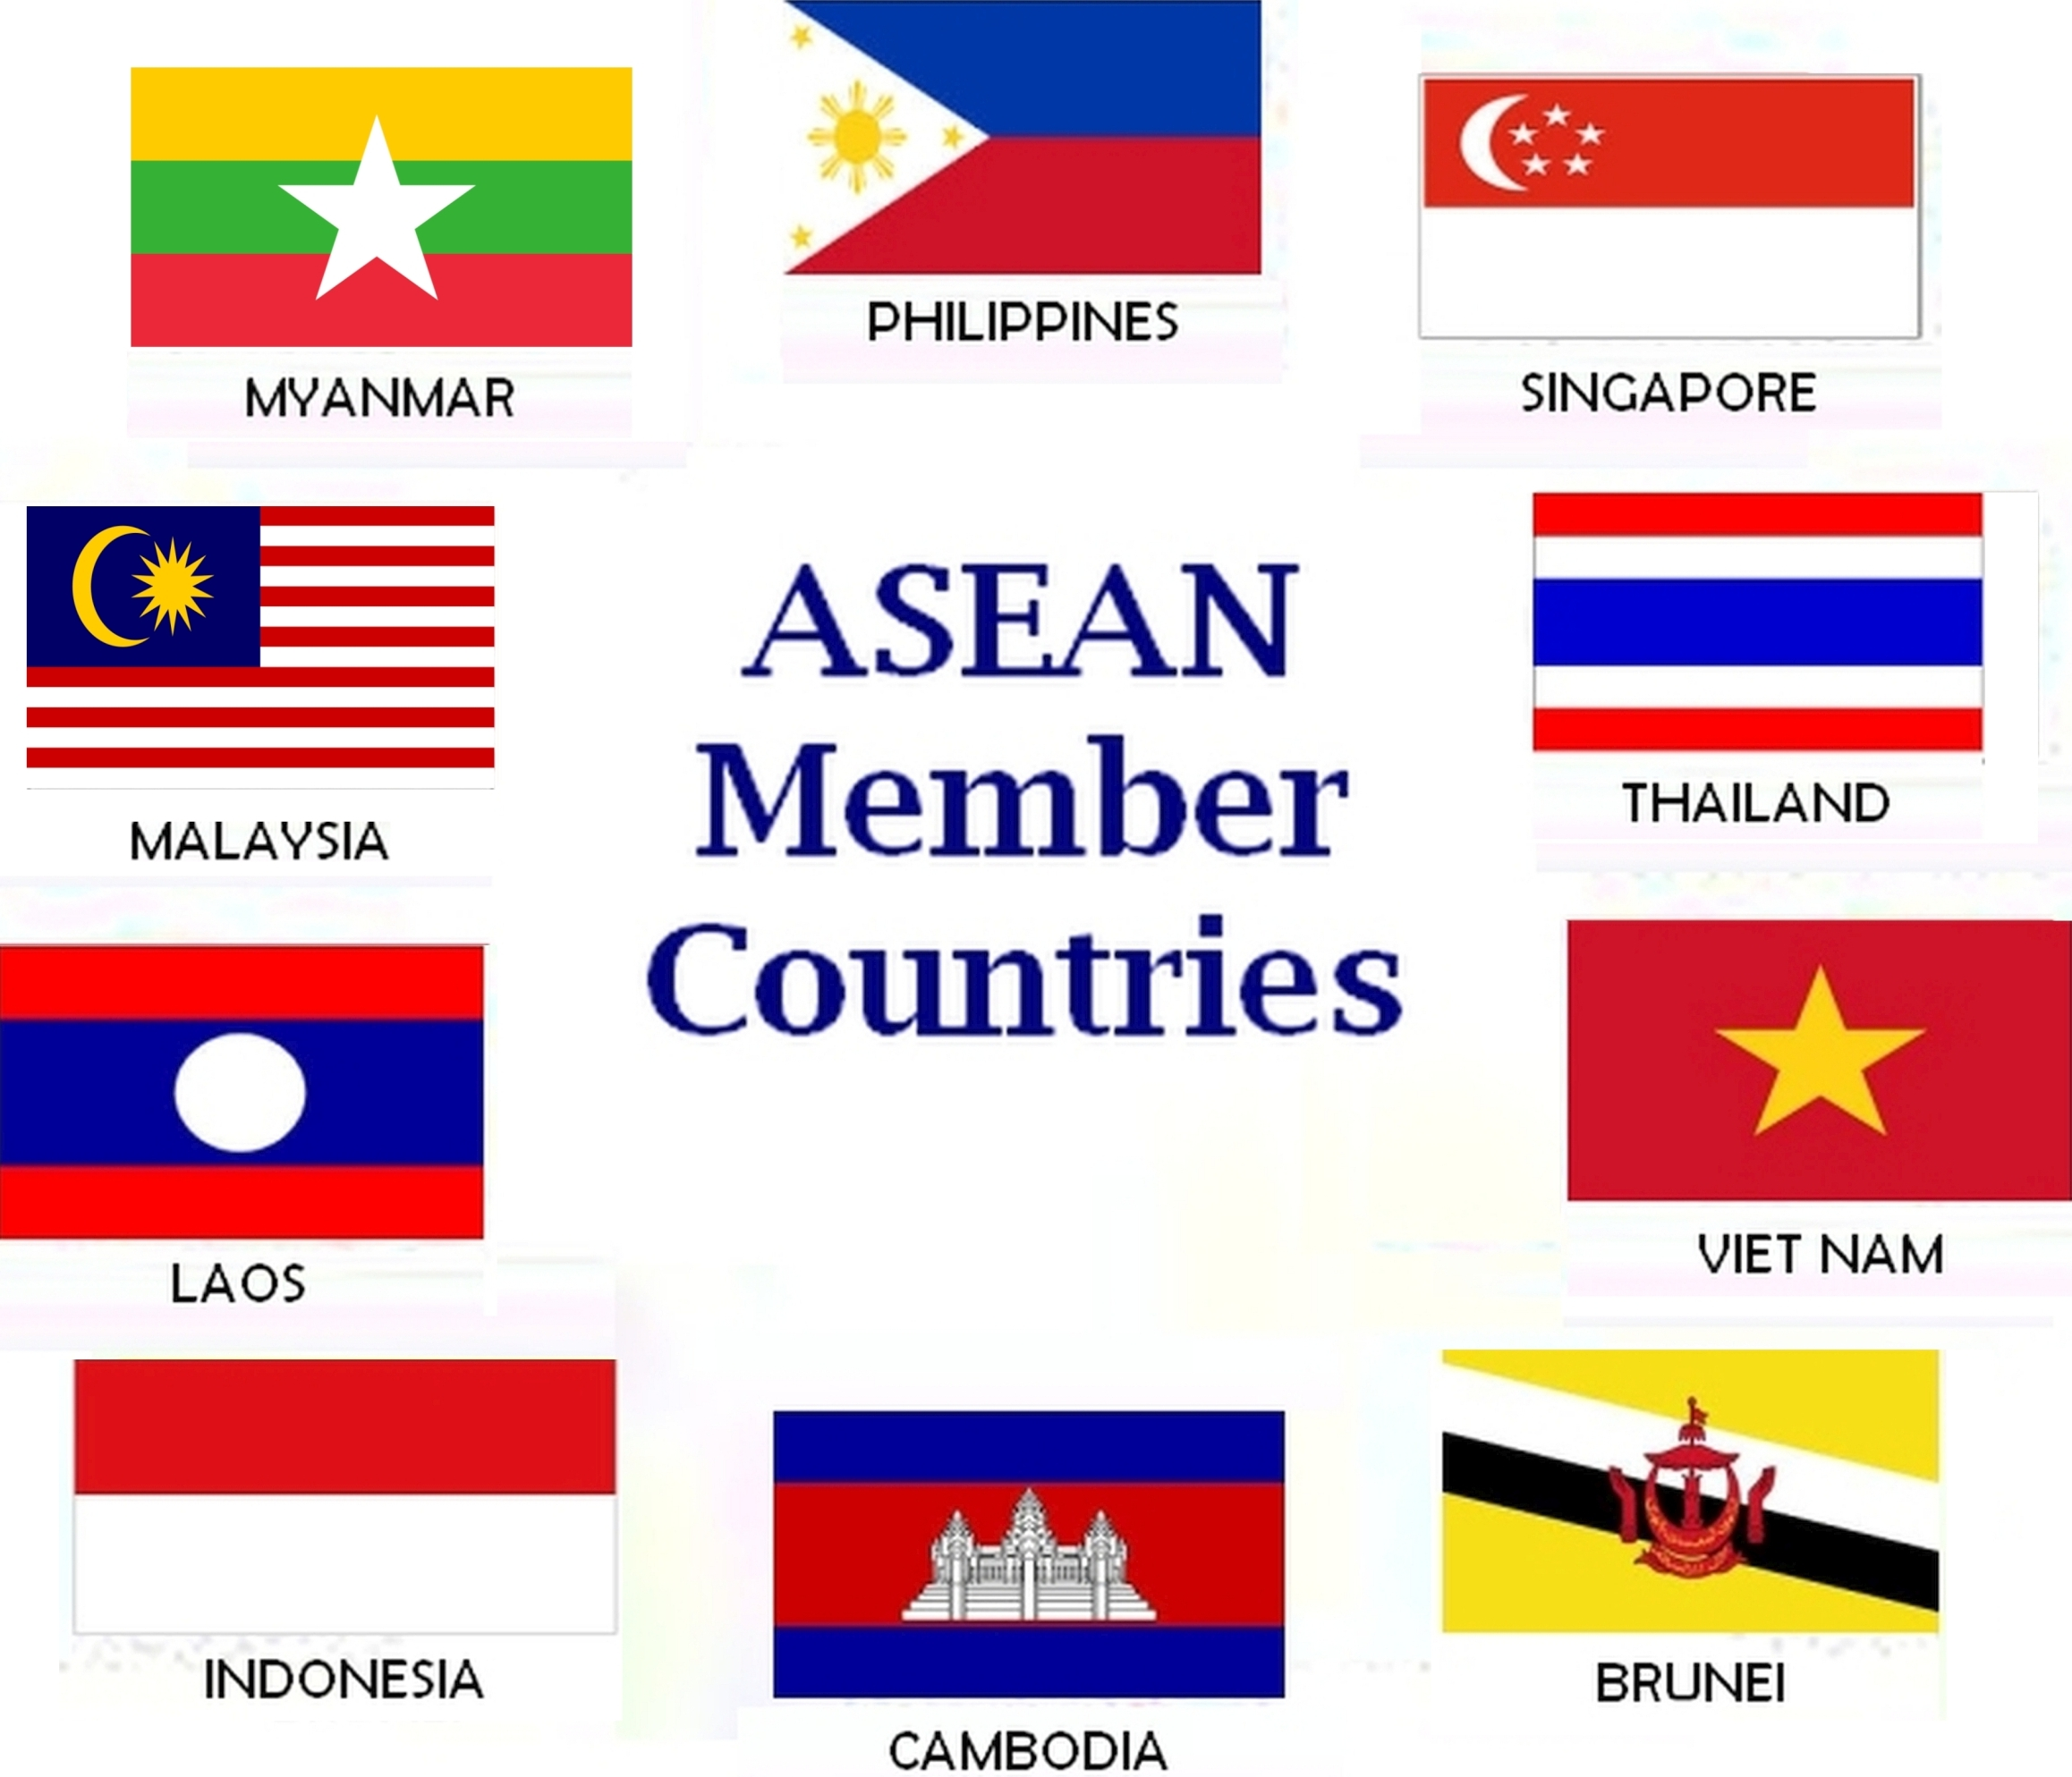

ASEAN Conference on Drug Use Prevention International Standards

December 5-7, 2016
National Institute for Science and Mathematics
Education Development (NISMED)
University of the Philippines
Diliman, Quezon City
PHILIPPINES

in cooperation with the:

Dangerous Drugs Board
Department of Education
Commission on Higher Education
Department of Social Welfare & Development
Philippine Information Agency
The Colombo Plan ICCE
and the
United Nations Office on Drugs and Crime





REGISTRATION
REGISTRATION FEE:
- Local (regular rate) PHP 5,000
- Early birds, DepED/CHED, and students PHP 4,500
- Foreign US$ 200

(includes conference materials, snacks, lunch, & cultural/educational tour)
REQUIREMENTS:
EARLY BIRD:
- Submitted accomplished online Registration Form and paid Registration Fee on or before November 4, 2016
- Emailed picture/scanned copy of proof of payment
DepED/CHED/students:
- Submitted accomplished online Registration Form and paid Registration Fee on or before November 4, 2016
- Emailed scanned copy of proof of payment
- Emailed picture/scanned copy of valid employee/student ID card
GENERAL INFORMATION:
- The registration fee is non-refundable but transferable, ONLY with the approval of Conference Organizers on or before November 18, 2016.
- Deadlines for:
-Early bird registration: 04 Nov 2016
-Online registration: 25 Nov 2016
Form of Payment
- Bank Check/Postal Money Order (payable to UP ASEAN Training Center for Preventive Drug Education)
- Cash-Account Name: Research and Development Foundation
PNB UP Campus PESO Acct. No. 393182500016
Metrobank Katipunan DOLLAR Acct. No. 0932093007705, Swift Code: MBTCPH

Day 2 – December 6, 2016 (Tuesday)
Moderator: Dr. Catalina S. Salazar
8:00–9:00 Thailand’s Adoption of a Family-Based Prevention Intervention
Dr. Methinin Pinyuchon
9:00–10:00 Indonesia’s Adoption of a Workplace-Based Prevention Intervention
BNN Dr. Paulina G. Padmohoedojo
10:00–10:30 SNACKS
10:30–11:30 Brunei’s Evidence-Based Environmental Policies on Drug Use Prevention
NCB Chief Raimawati Badarudin
11:30–12:30 Utilizing Life Skills in
Delivering Drug Prevention
in Secondary Schools
DepED Sta.Lucia HS
Philippines Mr. Jasper Jornales
12:30–1:30 LUNCH
1:30 onwards Cultural/Educational Tour (with packed snacks)

Day 3 – December 7, 2016 (Wednesday)
Moderators AM:Prof. Jaclyn Marie L. Cauyan
PM:Ms. Ma. Dulcelina O. Sebastian
8:00–9:00 Singapore’s Media-Based Drug Prevention
CNB Senior Manager Ng Guet Hui
9:00–10:00 Malaysia’s Community-Based Project in Preventive Drug Education
NADA Principal Assistant Director Hafidah binti Mohd @ Maasom
10:00–10:30 SNACKS
10:30–11:30 Bhutan’s Experience in Prevention Work
Ms. Naina Kala Gurung
11:30–12:30 LUNCH
12:30–1:30 International Centre for Credentialing and Education of Addiction Professionals (ICCE) Colombo Plan Initiatives
Director Mr. Tay Bian How
1:30–2:30 Philippine Initiatives
DDB PETID Chief Teresita C.Pineda
2:30–300 SNACKS
3:00–4:00 Closing Ceremonies
`
Conference Objectives

1. disseminate the crucial themes of the UNODC International Standards on Drug Use Prevention
2. provide a platform for sharing country experiences in the adoption of the international standards on drug use prevention in various settings and modalities

Conference Schedule

Day 1 – December 5, 2016 (Monday)
Moderators AM:Dr. Rosanelia T. Yangco
PM:Prof. Maria Cecilia V. Zamora

7:30–9:00 Registration
9:00–10:00 Opening Ceremonies
Orientation of Participants
10:00–10:30 SNACKS

10:30–11:30 Preventive Education in the ASEAN Context
ATCPDE Director Prof. Francis Grace Duka-Pante

Regional Advisor Olivier Lermet
UNODC Regional Office
Southeast Asia and the Pacific

11:30–12:30 Overview of the UNODC International Standards
12:30–1:30 LUNCH
1:30–2:30 Evidence-Based Prevention Interventions and Policies (Family and School)
2:30–3:30 Evidence-Based Prevention Interventions and Policies (Environmental and Community)
3:30–4:00 SNACKS
4:00–5:00 Evidence-Based Prevention Interventions and Policies (Workplace and Media)

Deadline of abstract: Aug 26, 2005
Paper for any of this strand is acceptable.

To register for the conference, visit:
http://www.pia.gov.ph/atcpde
Email us at
upaseanph@gmail.com

